Nepal College of Information Technology
Unit Test
Fall 2010
Program: B.E.IT/CE Time: 2 hrs
Semester: Fall (V) FM: 60
Subject: Numerical Methods PM: 30
Attempt all questions

1. a. Solve
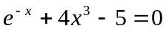
by Bisection method correct to two decimal place. [7]
b. Solve
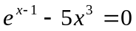
by secant method correct to 3 decimal place. [8]
2. a. Solve
x^{x}=100
OR
x logx=2.4
by N-R method correct to 4 decimal places. [8]
b. Solve
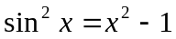
by fixed point iteration method 7
3. a. The population of a town in the decennial census was as given below: Estimate the population for the year 1895 by suitable Newton's method [7]

Year x: | 1891 | 1901 | 1911 | 1921 | 1931
Population y:(in thousand) | 46 | 66 | 81 | 93 | 101
b. The table below gives the temperature T ( in degree) and lenths l (in mm) of heated root. If
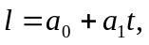 find the best values for 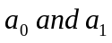 and hence the lenth when t=45⁰C [8]

t | 20 | 30 | 40 | 50 | 60 | 70
l | 800.3 | 800.4 | 800.6 | 800.7 | 800.9 | 801

4. a. Applying Lagrange's formula, find a cubic polynomial which approximate the following data [7]

x | -2 | -1 | 2 | 3
f(x) | -12 | -8 | 3 | 5

b. Write short notes on (Any two) [4x2]
i) Error in numerical computing
ii) Convergence of fixed point iteration methods
iii) Interpolation and Extrapolation.

